**Section 10.7 The Wave Equation**

**Contents**

* A vibrating string

**A vibrating string**

The following commands create and show an animation of the solution of the wave equation $u(x,t) = \sin(5x)\cos(5t),\ 0 < x < \pi,\ 0 < t < 2 \pi$. In the animation, $t = n\pi/50$.

X = 0:0.01:pi;

for n = 0:100

plot(X, sin(5*X)*cos(n*pi/10)), axis([0,pi,-2,2])

M(n+1) = getframe;

end

mplay(M,6)

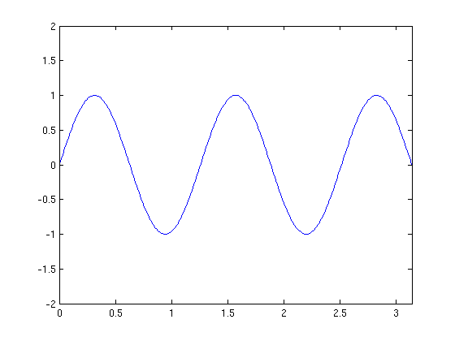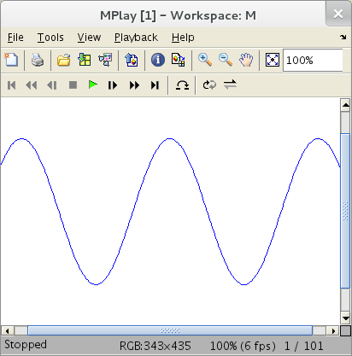

Published with MATLAB® 7.13